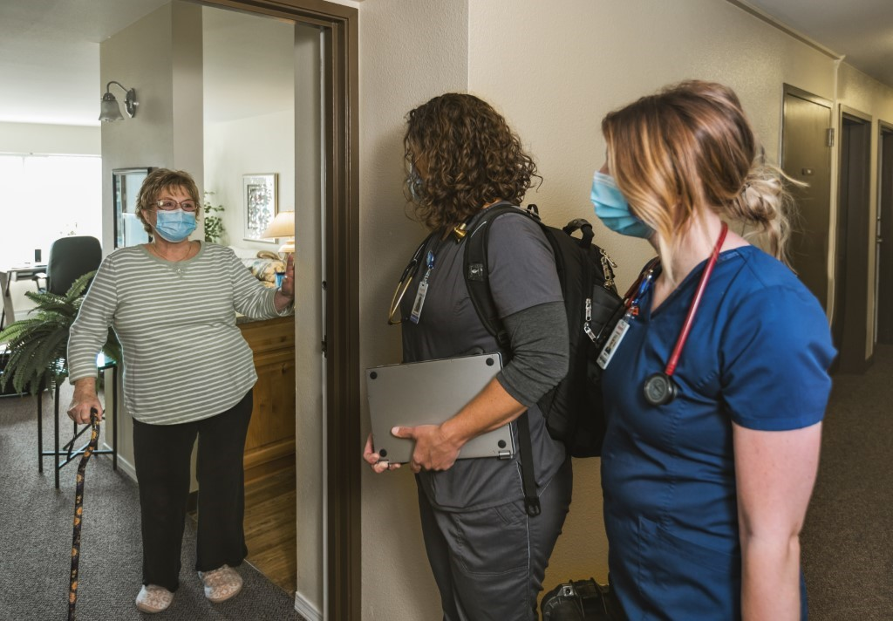
DispatchHealth brings the power of the hospital to the comfort of home

[Partner Name] is pleased to share that we are now partnering with DispatchHealth to offer our [patients/residents/clients] same-day in-home medical care for urgent but not-life-threatening injuries or illnesses. This service extends the capabilities of our team by preventing unnecessary visits to the ER or urgent care and helping you save on the total cost of care.
DispatchHealth medical teams can treat nearly everything an emergency room can (as long as it’s not life or limb-threatening). Common conditions include UTI’s, respiratory infections, COPD exacerbation, pneumonia, skin infections, dehydration, diarrhea, CHF exacerbation, symptoms associated with COVID-19, and many other common to complex illnesses and injuries. Watch this video for an in-depth walk-through of who they are, how they help and what they do, as told by a DispatchHealth provider team.
So, how much does a visit cost? DispatchHealth accepts most insurance, including Medicare and Medicare Advantage. In fact, the average out-of-pocket cost is just $5.44 for patients with Medicare and a secondary insurance.

How it works: Affordable in-home medical care is just a few simple steps away.
- Request care
DispatchHealth’s services can be requested by calling [XXX-XXX-XXXX], using their mobile app or visiting their website at dispatchhealth.com. DispatchHealth is available [X a.m. - X p.m.], seven days a week including holidays.
- Receive care at home
Their medical team arrives within a few hours. Each team consists of either a nurse practitioner or physician assistant, along with a medical technician. An ER physician is always available by phone for consultations. Medical teams always wear protective gear and arrive with sanitized equipment.
- They’ll take care of the rest
DispatchHealth will call in any prescriptions you might need, update your care team and handle billing directly with your insurance company.

To learn more, visit dispatchhealth.com.

